**Angular Notes and Code Examples**

Start a new Angular Project

* In terminal type - ng new – then name of project so = ng new angular-course
* Make sure that you are in the directory that you want the angular project to be stored in first.

Basic layout of an angular application

To Start the Sever

* Type npm start or ng serve.

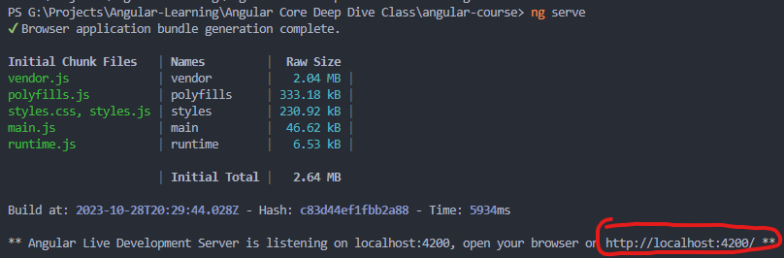

Site from link all the links on the sites take you to pages to help with coding in angular.

**Break down of how this page is created.**

Index.html is where everything is called to the <app-root> is whats called in for the app component to display the html and styling.

The selector for the component is app-root. It is what calls the entire component for the app component.

Your html code is in the app.component.html, currently the styling is there to but you can move it to the app.component.scss or .css instead of having it integrated in with your html.

